Университет ИТМО

Факультет ПИиКТ

Архитектура программных систем

Лабораторная работа №1

Выполнили:

Е Хэн p33111

Преподаватель:

**Задание**

Выбрать любую реально существующую систему и описать её в терминах UML. Желательно, чтобы система была не полностью информационной, но опиралась на информационную систему как показано в примере на лекции (Point of sale). Необходимо описать границы системы на разных уровнях, а также описать сценарии использования для нескольких Акторов.

**Требования к системе**

Jingdong(P2P)

**Функциональные:**

***Требования владельца сайта:***

1. ***The website must provide the ability to edit products. List products, edit prices, delete products***
2. ***The system should provide statistics on sales volume.***
3. ***The website must display the customer's evaluation of the product and the shopping experience.***
4. ***The homepage of the website should contain the contact information of the merchant and the logistics information of the goods.***
5. ***The website must contain advertising banner blocks so that the website owner can collect advertising fees.***

***Требования пользователей сайта:***

1. ***The website must be able to search for products by name and have the ability to search for vague information.***
2. ***The website must be able to sort products by price, evaluation, distance and other factors.***
3. ***The website should allow customers to evaluate products***
4. ***This website shall guarantee the entire transaction process.***

**Нефункциональные:**

1. ***The website must run normally in a modern browser (Chrome, Firefox, Edge, IE...). There are apps that can run on Android and iOS (recent versions)***
2. ***The site must be accessible to users on the Internet-by typing in the address and using a search engine on the Internet to search for results.***
3. ***The website needs to require sellers to register with their real names as a guarantee.***
4. ***The website must operate stably and can host up to 80 million users (China's online shopping is basically popular).***
5. ***The backend of the website must be written in JAVA or PHP. Apps should be written in Kotlin and Swift.***

|  |  |  |  |  |
| --- | --- | --- | --- | --- |
| № | ID | Полезность | Трудоемкость, человеко-час | Стабильность |
| *Требования владельцев сайта* | | | | |
| 1 | FR1 | Should have | 2 | Low |
| 2 | FR2 | Must have | 5 | High |
| 3 | FR3 | Can have | 1 | Mid |
| 4 | FR4 | Must have | 3 | Low |
| 5 | FR5 | Should have | 2 | Low |
| *Требования пользователей сайта:* | | | | |
| 1 | FR6 | Should have | 3 | High |
| 2 | FR7 | Must have | 4 | Mid |
| 3 | FR8 | Can have | 3 | Mid |
| 4 | FR9 | Should have | 2 | High |
| 5 | SR1 | Mush have | 10 | Low |
| *Нефункциональные требования* | | | | |
| 1 | N1 | Should have | 8 | Low |
| 2 | N2 | Should have | 10 | Low |
| 3 | N3 | Must have | 3 | High |
| 4 | N4 | Should have | 7 | Low |
| 5 | N5 | Must have | 2 | High |

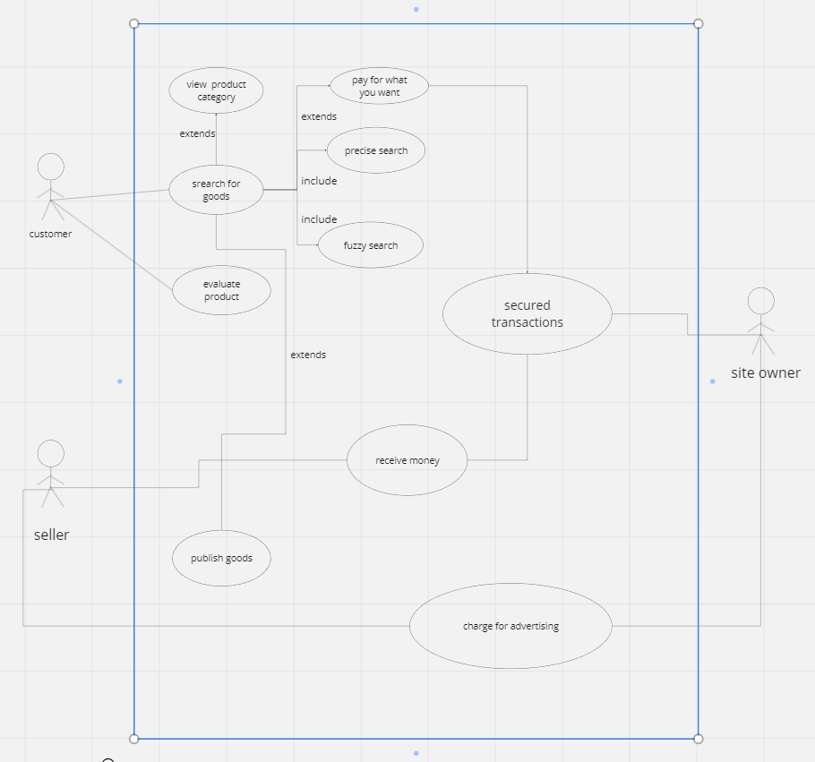

|  |  |
| --- | --- |
| **Имя прецедента** | Search for goods |
| **ID прецедента** | 1 |
| **Краткое описание** | Customers search for products by product name(Support fuzzy search). |
| **Актёры, задействованные в прецеденте** | Customers |
| **Предусловия** | Customers want to buy something and there are some sellers who sell something customers want. |
| **Основной поток** | 1. Customer search goods by name. 2. Customer enter the goods’ page |
| **Постусловия** | Customer read the info of goods |
| **Альтернативные потоки** | If there is no goods which customer wants, site will show similar goods. |

|  |  |
| --- | --- |
| **Имя прецедента** | Publish goods |
| **ID прецедента** | 2 |
| **Краткое описание** | Seller publish the goods on the site |
| **Актёры, задействованные в прецеденте** | Seller |
| **Предусловия** | The seller is already registered on the website |
| **Основной поток** | 1. Sellers prepare the info and photos of goods. 2. Sellers set the key words of goods. 3. Sellers publish goods. |
| **Постусловия** | The good is published. |
| **Альтернативные потоки** | The product is illegal and not allowed to be published. |

|  |  |
| --- | --- |
| **Имя прецедента** | Guarantee the transaction |
| **ID прецедента** | 3 |
| **Краткое описание** | The site owner (third party) guarantees the transaction. |
| **Актёры, задействованные в прецеденте** | Site owner |
| **Предусловия** | нет |
| **Основной поток** | 1. The owner collects the info of the customers and sellers. 2. Collect the seller's deposit. 3. Collect payments from customers. 4. Transfer the money to the seller’s account when both parties agree. |
| **Постусловия** | After the transaction is completed, the user can evaluate the seller and the product. |
| **Альтернативные потоки** | The transaction fails, the owner collects the message and handles it accordingly |

**Вывод:**

I have understood what a use case is and how we find it in our lives. Understand how to read UML diagrams based on information or your own UML diagrams. This is a good method at work. I will try to use UML to analyze various requirements in the future.